GeoMeasure API
Geospatial File Measurement API for KML and ESRI Shapefile Data
A backend API built with Python and FastAPI for uploading, validating, processing, and measuring geospatial files.
The application supports KML files and ZIP archives containing ESRI Shapefiles, with CRS-aware area and length calculations.

1. Overview
GeoMeasure API was developed for the AEREO Software Development Intern assignment.
The API accepts geospatial files and processes their individual features to extract:
- Feature ID/index
- Geometry type
- Geometry
- CRS
- Properties
- Measurements
The supported measurements are:
Geometry Type | Measurement
Point | No measurement
MultiPoint | No measurement
LineString | Length
MultiLineString | Length
Polygon | Area
MultiPolygon | Area
A key requirement of the implementation is that measurements must not be calculated directly using latitude/longitude degrees.
When the input dataset uses a geographic CRS such as EPSG:4326, the system automatically selects a suitable projected UTM CRS before calculating area or length.

2. Key Features
- KML file processing
- ESRI Shapefile ZIP processing
- CRS detection and validation
- Automatic UTM CRS selection
- Projected-CRS-aware measurements
- Polygon area calculation
- LineString length calculation
- Point handling
- Geometry validation
- Geometry repair where possible
- Feature-level error isolation
- Secure ZIP extraction
- File size and archive limits
- SHA-256 duplicate detection
- Pagination and geometry filtering
- Summary endpoint
- Data-quality reporting
- GeoJSON export
- Structured API errors
- Temporary file cleanup
- Automated test suite
- Performance benchmarking

3. Technology Stack
Component | Technology
Language | Python 3.11+
API Framework | FastAPI
ASGI Server | Uvicorn
Data Validation | Pydantic v2
Geospatial Data | GeoPandas
Geometry Operations | Shapely
CRS / Projection | PyProj
Geospatial I/O | Pyogrio
Testing | Pytest
Linting / Formatting | Ruff

4. Setup
4.1 Prerequisites
Install:
- Python 3.11 or newer
- Git
No database or external infrastructure is required for the current implementation.

4.2 Clone the Repository
git clone <repository-url>
cd geomasure-api

4.3 Create a Virtual Environment
Windows
python -m venv .venv
.venv\Scripts\activate
Linux / macOS
python3 -m venv .venv
source .venv/bin/activate

4.4 Install Dependencies
pip install -r requirements.txt

4.5 Run the Application
uvicorn app.main:app --reload
The API will be available at:
http://127.0.0.1:8000

4.6 API Documentation
FastAPI automatically provides interactive API documentation.
Swagger UI:
http://127.0.0.1:8000/docs
ReDoc:
http://127.0.0.1:8000/redoc

5. Configuration
The application supports environment-based configuration.
Example configuration:
APP_NAME=GeoMeasure API
APP_VERSION=1.0.0
MAX_UPLOAD_MB=25
MAX_ZIP_FILES=25
MAX_ZIP_UNCOMPRESSED_MB=100
STORAGE_DIR=output
LOG_LEVEL=INFO
An example environment file is provided as:
.env.example

6. API
6.1 Endpoint Overview
Method | Endpoint | Purpose
POST | /api/files/ | Upload and process a geospatial file
GET | /api/files/{file_id} | Retrieve file information
GET | /api/files/{file_id}/measurements/ | Retrieve feature measurements
GET | /api/files/{file_id}/summary/ | Retrieve measurement summary
GET | /api/files/{file_id}/quality/ | Retrieve processing quality information
GET | /api/files/{file_id}/geojson | Export processed features as GeoJSON
GET | /health | Health check

7. Upload File
Endpoint
POST /api/files/
The endpoint accepts:
- .kml
- .zip containing an ESRI Shapefile
Example Request
curl -X POST \
-F "file=@examples/sample.kml" \
http://127.0.0.1:8000/api/files/
Example Response
{
"id": "file-id",
"filename": "sample.kml",
"status": "COMPLETED",
"source_crs": "EPSG:4326",
"measurement_crs": "EPSG:32644",
"feature_count": 3
}
The response provides the identifier required for subsequent API requests.

8. Get File Information
Endpoint
GET /api/files/{file_id}
Example
curl http://127.0.0.1:8000/api/files/<file_id>
The response includes information such as:
- File ID
- Filename
- Status
- Source CRS
- Measurement CRS
- Feature count
- Processing information
- Warnings where applicable

9. Get Measurements
Endpoint
GET /api/files/{file_id}/measurements/
The endpoint returns measurements for individual features.
Pagination
Example:
GET /api/files/{file_id}/measurements/?page=1&page_size=20
The maximum page size is 100.
Geometry Filtering
Example:
GET /api/files/{file_id}/measurements/?geometry_type=Polygon
Example Response
{
"items": [
{
"feature_id": "Block A",
"feature_index": 0,
"geometry_type": "Polygon",
"measurement_type": "area",
"value": 35970.48,
"unit": "m²"
}
]
}

10. Get Summary
Endpoint
GET /api/files/{file_id}/summary/
The summary provides aggregated information including:
- Total feature count
- Geometry type counts
- Total polygon area
- Total line length
- Source CRS
- Measurement CRS
- Processing status
Example
{
"feature_count": 3,
"total_area": 100717.19,
"total_length": 991.21,
"area_unit": "m²",
"length_unit": "m",
"measurement_crs": "EPSG:32644"
}

11. Quality Report
Endpoint
GET /api/files/{file_id}/quality/
The quality endpoint provides information about the reliability of processing.
It reports information such as:
- Total features
- Successful features
- Failed features
- Repaired geometries
- Invalid geometries
- Unsupported geometries
- Warnings
This is useful when a dataset contains a mixture of valid and problematic features.

12. GeoJSON Export
Endpoint
GET /api/files/{file_id}/geojson
The endpoint returns the processed features as a GeoJSON FeatureCollection.
The exported GeoJSON uses WGS84 / EPSG:4326.
Example structure:
{
"type": "FeatureCollection",
"features": [
{
"type": "Feature",
"geometry": {},
"properties": {}
}
]
}

13. Health Check
Endpoint
GET /health
Example:
curl http://127.0.0.1:8000/health
Used to verify that the application is running correctly.

14. HTTP Status Codes
Status Code | Meaning
200 | Successful request
400 | Invalid request
404 | File not found
413 | File too large
415 | Unsupported file type
422 | Request validation error
500 | Internal processing error
Errors follow a structured format:
{
"error": {
"code": "UNSUPPORTED_FILE_TYPE",
"message": "Only KML and Shapefile ZIP files are supported."
}
}

15. Architecture
The application follows a layered architecture that separates API handling, file processing, geospatial processing, measurement, reporting, and storage.
flowchart TD
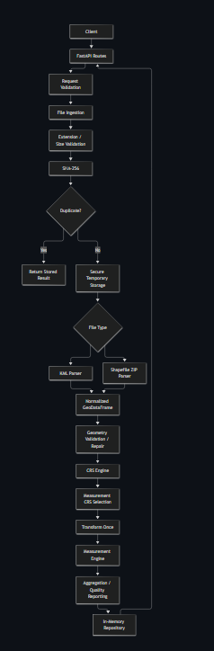

16. Application Structure
The major application layers are:
app/
├── api/
│ ├── routes_files.py
│ └── routes_health.py
│
├── core/
│ ├── exceptions.py
│ ├── logging.py
│ └── security.py
│
├── models/
│ ├── enums.py
│ └── schemas.py
│
├── services/
│ ├── ingestion.py
│ ├── parser.py
│ ├── geometry.py
│ ├── crs.py
│ ├── measurement.py
│ ├── processor.py
│ ├── serialization.py
│ └── reporting/
│ └── quality.py
│
└── storage/
└── memory.py
API Layer
Responsible for:
- HTTP routes
- Request handling
- Query validation
- Response generation
Core Layer
Contains:
- Security utilities
- Application exceptions
- Logging configuration
Models
Contains:
- Enumerations
- Pydantic schemas
- API response models
Services
Contains the core business logic:
- File ingestion
- Parsing
- Geometry processing
- CRS selection
- Measurement
- Serialization
- Quality reporting
Storage
Contains the repository implementation used to store processed results.

17. File-Processing Flow
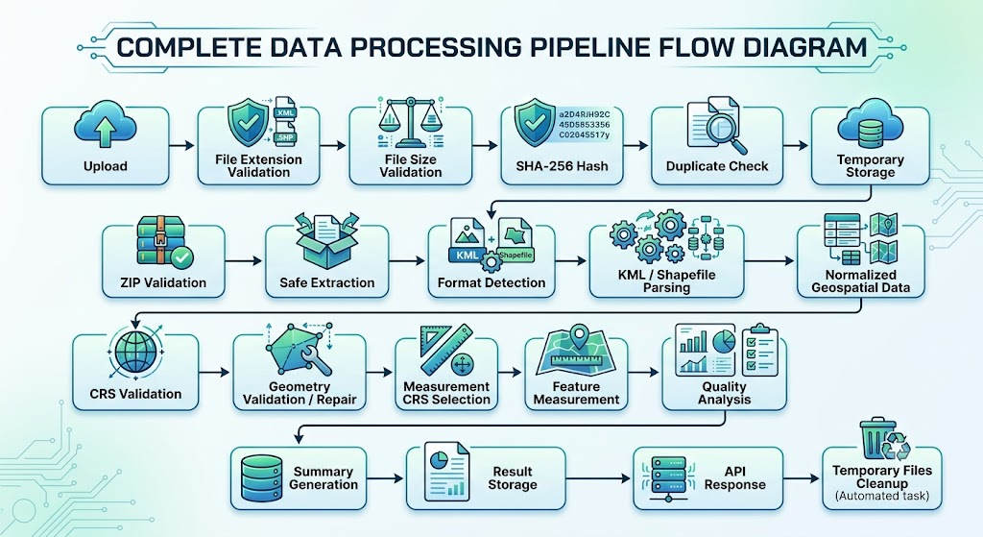

18. KML Processing
KML files are parsed using the standard Python XML library.
KML coordinates are treated as:
EPSG:4326 / WGS84
The parser extracts:
- Placemark identifiers
- Geometry
- Geometry type
- Properties
When a Placemark has an explicit id, it is preserved as the feature identifier.
Otherwise, the deterministic feature index is used.

19. Shapefile Processing
The API accepts an ESRI Shapefile packaged as a ZIP archive.
The archive is expected to contain:
.shp
.shx
.dbf
.prj
The .prj file is required because the application needs CRS information for reliable measurement.
If CRS information is missing or unreadable, processing fails with an appropriate error rather than producing potentially incorrect measurements.

20. Measurement Calculation Flow
Measurements are calculated only after geometry and CRS processing.
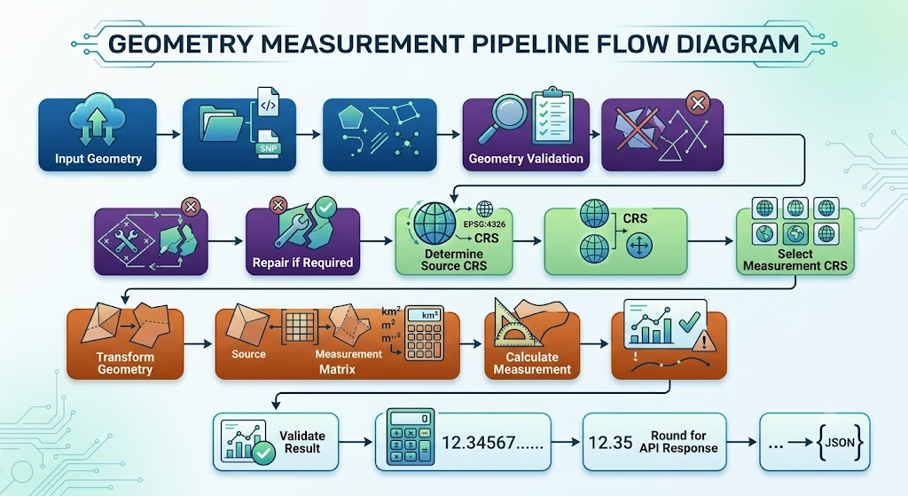
21. Geometry Measurement Rules
Point
No area or length is calculated.
measurement = null
MultiPoint
No area or length is calculated.
LineString
Length is calculated:
length = geometry.length
MultiLineString
Total length is calculated using the projected geometry.
Polygon
Area is calculated:
area = geometry.area
MultiPolygon
Total polygon area is calculated using the projected geometry.

22. CRS Handling
CRS handling is a core part of the implementation.
A geographic CRS represents positions using angular coordinates.
For example:
EPSG:4326
uses longitude and latitude in degrees.
Calculating:
polygon.area
directly on such coordinates does not produce a meaningful area in square metres.
Therefore, the application never intentionally performs area or length measurements directly on latitude/longitude coordinates.

23. Automatic UTM Selection
When the source CRS is geographic, the application selects a suitable UTM zone using the dataset location.
The general UTM zone calculation is based on longitude.
For the northern hemisphere:
EPSG = 32600 + zone
For the southern hemisphere:
EPSG = 32700 + zone
The resulting projected CRS is then used for measurement.
For example:
EPSG:4326
↓
Dataset centroid
↓
UTM Zone
↓
Projected CRS
↓
Area / Length

24. Projected CRS Handling
If the input data already uses a suitable projected CRS with metric units, the application can use that CRS directly.
If the projected CRS uses another unit, such as feet, the appropriate unit conversion is considered when calculating measurements.
Web Mercator datasets are reprojected to a suitable UTM CRS before measurement.

25. CRS Limitations
The current implementation documents several CRS limitations.
These include:
- Very large geographic extents
- Antimeridian-crossing datasets
- Special Norway UTM zones
- Special Svalbard UTM zones
- Areas beyond normal UTM latitude limits
For datasets spanning a large longitudinal range, the application can generate a warning because a single UTM zone may not be optimal for the entire dataset.

26. Geometry Validation and Repair
Geometries are validated before measurement.
The system checks for:
- Missing geometry
- Empty geometry
- Invalid geometry
- Degenerate geometry
- Unsupported geometry types
Where possible, invalid geometries are repaired.
After repair, the resulting geometry is checked to ensure that it remains compatible with the expected geometry family.
If a feature cannot be safely repaired, that feature is marked as failed.

27. Feature-Level Error Isolation
The processing pipeline isolates errors at the feature level.
For example:
Feature 0 → Valid Polygon → Processed
Feature 1 → Invalid Geometry → Failed
Feature 2 → Valid Line → Processed
Feature 3 → Point → Processed
The failure of Feature 1 does not automatically cause the entire dataset to fail.
This allows valid features to continue processing while problematic features are reported.
A file is considered failed only when no feature can be successfully processed.

28. ZIP Security
Uploaded ZIP archives are considered untrusted input.
The application validates:
- Absolute paths
- Drive-qualified paths
- Parent-directory traversal
- Symbolic links
- Encrypted entries
- Entry count
- Uncompressed archive size
- Shapefile components
Dangerous paths such as:
../../file.txt
are rejected.
Archives are extracted only into controlled temporary directories.

29. Duplicate Detection
The uploaded file is fingerprinted using SHA-256.
The hash is used to detect identical uploads during the application's lifetime.
Example:
First upload
↓
Process file
↓
Store result

Same file uploaded again
↓
SHA-256 match
↓
Return existing result
This avoids unnecessarily processing identical files multiple times.
The SHA-256 value is treated only as a content fingerprint and is not used as an authentication mechanism.

30. Quality Reporting
The quality reporting layer provides additional information about the processing result.
It can identify:
- Total features
- Successfully processed features
- Failed features
- Repaired geometries
- Unsupported geometries
- Warnings
- Processing status
This helps users understand not only the measurement result but also the quality of the source dataset.

31. Storage
The current implementation uses an in-memory repository.
Advantages
- Simple
- Fast
- Easy to test
- No external database dependency
- Appropriate for the assignment scope
Limitation
Results are lost when the application restarts.
The storage layer is isolated so that a persistent implementation can be introduced later, for example:
FastAPI
↓
Repository Interface
↓
PostgreSQL / PostGIS

32. Logging
The application records useful processing information such as:
- File ID
- Filename
- Processing start
- Processing completion
- Processing duration
- Feature count
- Warnings
- Errors
The application avoids logging complete file contents or full geometry data.

33. Design Decisions
33.1 FastAPI
Chosen
FastAPI
Alternative
Django REST Framework
Reason
FastAPI provides a lightweight API-focused architecture, automatic OpenAPI documentation, strong request validation, and good support for Python type hints.

33.2 GeoPandas + Shapely + PyProj
Chosen
GeoPandas, Shapely, PyProj
Alternative
Using only a lower-level GDAL-based implementation
Reason
The selected libraries provide a clear separation of responsibilities:
GeoPandas → Geospatial dataset handling
Shapely → Geometry operations
PyProj → CRS and coordinate transformation
This keeps the processing pipeline easier to understand and maintain.

33.3 Automatic UTM Selection
Chosen
Automatically select a UTM CRS for geographic datasets.
Alternative
Calculate measurements directly in EPSG:4326.
Reason
Latitude and longitude are angular coordinates. Direct planar calculations on degrees can produce incorrect area and distance values.
The projected CRS approach provides measurements in meaningful linear units such as metres.

33.4 One Measurement CRS Per Dataset
Chosen
Select one measurement CRS for the dataset.
Alternative
Select a different CRS for every feature.
Reason
Using one measurement CRS provides consistent calculations and makes dataset-level totals easier to interpret.

33.5 Feature-Level Error Isolation
Chosen
Process valid features independently.
Alternative
Fail the entire dataset when one feature fails.
Reason
Real-world geospatial datasets can contain occasional malformed features. Isolating errors allows useful data to continue processing.

33.6 Secure Temporary ZIP Extraction
Chosen
Validate and extract ZIP archives into temporary directories.
Alternative
Directly extract archive contents without validation.
Reason
Uploaded archives are untrusted. Validation protects against path traversal, excessive archive expansion, symbolic links, and other unsafe archive contents.

33.7 In-Memory Storage
Chosen
In-memory repository.
Alternative
PostgreSQL/PostGIS.
Reason
The assignment focuses on geospatial processing rather than persistent infrastructure. In-memory storage keeps the implementation simple and easy to run locally.
The storage layer can later be replaced with a persistent repository.

33.8 No Frontend
Chosen
Backend API only.
Alternative
React or Next.js frontend.
Reason
The assignment is specifically focused on the API and backend processing. FastAPI's Swagger interface is sufficient for testing and demonstrating the API.

34. Security Considerations
Security-related protections implemented include:
- Upload size limits
- ZIP entry limits
- Uncompressed archive limits
- Path traversal prevention
- Symbolic link rejection
- Encrypted ZIP rejection
- Temporary directory isolation
- File type validation
- Structured error handling
The current assignment implementation does not include authentication or authorization.

35. Testing
The project includes automated tests covering:
- File uploads
- KML parsing
- Shapefile parsing
- ZIP security
- CRS handling
- EPSG:4326
- Projected CRS
- Northern UTM
- Southern UTM
- Feet-based CRS
- Web Mercator
- Geometry validation
- Geometry repair
- Degenerate geometries
- Point handling
- Polygon measurements
- Line measurements
- Feature-level failure isolation
- Duplicate detection
- Pagination
- Geometry filtering
- Summary endpoint
- Quality endpoint
- GeoJSON export
- API errors
- Edge cases

36. Test Results
Final test execution:
pytest -v

105 passed, 1 warning in 1.34s
All project tests passed successfully.
The warning is a dependency deprecation warning related to HTTPX and Starlette's test client. It does not represent a project test failure.

37. Code Quality
Ruff was used for linting and formatting.
Command:
ruff check .
Result:
All checks passed!
Formatting:
ruff format --check .
Result:
42 files already formatted

38. Performance Benchmark
A local benchmark was performed with datasets containing different numbers of features.
Features | File Size | Median Time | Time / Feature
10 | 2.2 KB | 3 ms | 0.28 ms
100 | 21.3 KB | 8 ms | 0.08 ms
1,000 | 223.6 KB | 60 ms | 0.06 ms
These values were measured in a local development environment and should not be interpreted as production infrastructure benchmarks.

39. Sample Results
KML Example
Source CRS:
EPSG:4326
Measurement CRS:
EPSG:32644
Example measurements:
Feature | Geometry | Measurement
Block A | Polygon | 35,970.48 m²
Block B | Polygon | 64,746.71 m²
Road/Line | LineString | 991.21 m
Location | Point | No measurement
Total polygon area:
100,717.19 m²

Shapefile Example
Example expected areas:
Feature | Area
Plot 1 | 20,000 m²
Plot 2 | 4,000 m²
Plot 3 | 36,000 m²
Total:
60,000 m²

40. Edge Cases Tested
Duplicate Upload
HTTP 200
duplicate = true
same file ID
Observed duplicate lookup response time:
approximately 8 ms
Unsupported File
.txt
Result:
HTTP 415
UNSUPPORTED_FILE_TYPE
Invalid File ID
Result:
HTTP 404
FILE_NOT_FOUND
Invalid Pagination
Example:
page_size=500
Result:
HTTP 400
INVALID_REQUEST
The maximum supported page size is 100.

41. Limitations
The current version intentionally has several limitations.
In-Memory Storage
Data is not persistent across application restarts.
UTM Special Cases
Special Norway and Svalbard UTM zone rules are not fully implemented.
Antimeridian
Antimeridian-crossing datasets require additional handling.
Large Datasets
The current implementation is designed for the assignment scope rather than extremely large datasets.
3D Measurements
Measurements are currently two-dimensional and ignore Z coordinates.
Authentication
Authentication and authorization are not implemented.
Distributed Processing
The current version does not use background workers or distributed processing.

42. Future Enhancements
Possible future improvements include:
- PostgreSQL/PostGIS persistent storage
- Object storage such as S3
- Background processing for large files
- Authentication and authorization
- Rate limiting
- Advanced CRS selection
- Improved antimeridian handling
- Streaming/chunk-based processing
- Additional geospatial operations
- Interactive map visualization
- Distributed processing

43. Project Structure Summary
Client
↓
FastAPI
↓
Validation
↓
Ingestion
↓
Security
↓
Parser
↓
Geometry
↓
CRS
↓
Measurement
↓
Quality / Summary
↓
Storage
↓
Response
The architecture intentionally keeps these responsibilities separated so individual components can be tested and extended independently.

44. Assignment Requirement Mapping
AEREO Requirement | Implementation
Python backend | Python
FastAPI/Django | FastAPI
POST /api/files/ | Implemented
KML upload | Implemented
Shapefile ZIP upload | Implemented
Feature ID/index | Implemented
Geometry type | Implemented
Geometry | Implemented
CRS | Implemented
Polygon area | Implemented
LineString length | Implemented
Point handling | Implemented
Projected CRS measurement | Implemented
Automatic UTM selection | Implemented
File status | Implemented
Measurements endpoint | Implemented
Summary | Implemented
Quality reporting | Implemented
GeoJSON export | Implemented
Error handling | Implemented
Secure ZIP processing | Implemented
README | Implemented
Architecture explanation | Implemented
Measurement flow | Documented
CRS handling | Documented
Design decisions | Documented
Automated tests | 105 passing

45. Running the Test Suite
After installing dependencies:
pytest -v
Expected:
105 passed
Run linting:
ruff check .
Expected:
All checks passed!
Check formatting:
ruff format --check .
Expected:
42 files already formatted

46. Final Status
GeoMeasure API
Feature / Component | Status
FastAPI Backend | ✓
KML Processing | ✓
Shapefile Processing | ✓
CRS Handling | ✓
Automatic UTM Selection | ✓
Geometry Validation | ✓
Geometry Repair | ✓
Area Measurement | ✓
Length Measurement | ✓
Point Handling | ✓
ZIP Security | ✓
Duplicate Detection | ✓
Quality Reporting | ✓
GeoJSON Export | ✓
Pagination | ✓
Error Handling | ✓
Automated Testing | ✓
Performance Benchmark | ✓
Documentation | ✓
Code Quality | ✓
────────────────────────────────────
Tests 105 Passed
Ruff Clean
Status Completed

47. Conclusion
GeoMeasure API provides a focused backend solution for processing KML and ESRI Shapefile data and calculating CRS-aware geospatial measurements.
The implementation goes beyond basic file parsing by including:
- Secure file ingestion
- Geometry validation and repair
- Automatic projected CRS selection
- Feature-level error isolation
- Duplicate detection
- Quality reporting
- GeoJSON export
- Automated testing
- Performance validation
The most important technical consideration is the handling of coordinate reference systems. Geographic latitude/longitude coordinates are not treated as planar measurement coordinates. Instead, the system transforms geographic data into an appropriate projected CRS before calculating area or length.
The final implementation has been validated with 105 automated tests, all passing successfully, along with Ruff code-quality checks and local performance benchmarks.
The architecture remains intentionally modular, allowing future extensions such as PostGIS storage, object storage, background processing, authentication, and advanced geospatial operations without changing the fundamental processing pipeline.

